Macrosystems EDDIE:

Macro-Scale Feedbacks

**Instructor’s Manual**

# Module Description

Environmental phenomena are often driven by multiple factors that interact across space and over time. In freshwater lakes and reservoirs worldwide, carbon cycling and subsequent carbon dioxide (CO2) and methane (CH4) fluxes are changing due to local, regional, and continental drivers. In this module, students will learn how to set up a lake ecosystem model and "force" the model with climate scenarios to test hypotheses about how local and global drivers will interact to promote or suppress greenhouse gas fluxes in different lakes. The overarching goal of this module is for students to explore new modeling and computing tools while learning fundamental concepts about how non-linear macrosystem-level phenomena (e.g., lake greenhouse gas fluxes) can occur through macro-scale feedbacks.

*Note to instructors:* We recommend this module to be used in upper-level (junior and senior) undergraduate aquatic/freshwater ecology, ecosystem ecology, and global change ecology courses. Some of the modeling in this module examines lake ecosystem ecology concepts not generally covered in introductory ecology courses. Thus, we highly recommend that instructors review module materials before teaching the module and tailor module materials (i.e., Instructor PowerPoint, Student Handout) to the individual needs of their classrooms. In these materials, we purposely included additional background information that may not be necessary for more advanced classrooms.

# Pedagogical Connections

|  |  |  |
| --- | --- | --- |
| **Phase** | **Functions** | **Examples from this module** |
| Engagement | Introduce topic, gauge students’ preconceptions, call up students’ schemata | Short introductory lecture |
| Exploration | Engage students in inquiry, scientific discourse, evidence-based reasoning | Development of hypotheses of how climate change affects carbon cycling in lakes; testing of these hypotheses by forcing lake models with climate scenarios to see how the lakes respond |
| Explanation | Engage students in scientific discourse, evidence-based reasoning | In-class discussion of the effects of the different climate scenarios on different lakes |
| Expansion | Broaden students’ schemata to account for more observations | Assessing macro-scale feedbacks by examining the effect of climate scenarios on global warming potentials; comparing how multiple lakes respond to the same scenarios |
| Evaluation | Evaluate students’ understanding, using formative and summative assessments | In-class discussion of how local warming and lake greenhouse gas fluxes can create macro-scale feedbacks altering global climate change; discussion questions in the student handout |

# Learning Objectives

By the end of this module, students will be able to:

* Understand the concepts of macrosystems ecology and macro-scale feedbacks, and how different ecological processes can interact at local, regional, and continental scales.
* Simulate greenhouse gas fluxes in multiple lakes using ecosystem models set up with publicly-available high-frequency sensor datasets (Activity A).
* Test the effects of a climate scenario on the different lake models and examine how the timing and magnitude of greenhouse gas fluxes change with climate warming (Activity B).
* Examine how local conditions may alter the timing and magnitude of greenhouse gas fluxes from lakes to affect global climate change (Activity C).
* Predict how lake greenhouse gas fluxes may both respond to and amplify changing climate.

# How to Use this Module

This entire module can be completed in one 3-4 hour lab period or three 60-minute lecture periods for upper-level undergraduate students. Activities A and B could be completed with upper-level students in two 60-minute lecture periods, with Activity C as a separate add-on activity, though as noted above, this will depend on the student experience level and familiarity with module content.

Quick overview of the activities in this module

* Activity A: Explore and run a lake ecosystem model in R
* Activity B: Generate hypotheses about how lake CO2 and CH4 fluxes will respond to climate warming, and model how different lakes respond
* Activity C: Calculate global warming potentials for lakes for baseline and climate scenarios, compare greenhouse gas fluxes among lakes, and make predictions about the effects of lake greenhouse gas emissions due to macro-scale feedbacks at the local, regional, and global scales.

In this module, we have developed pre-made scenarios based on downscaled climate scenarios. For each lake (Falling Creek, Mendota, Sunapee, and Toolik), there are three pre-made climate scenarios. Each scenario represents a year-round increase in air temperatures (+2°C, +4°C, or +6°C) relative to baseline historical conditions. We encourage instructors to have different teams of students complete different lake ecosystem and scenario combinations to compare and contrast their model outputs.

Pre-made climate scenario files for each lake are named as follows:

1. met_hourly_plus2.csv
2. met_hourly_plus4.csv
3. met_hourly_plus6.csv

# Module Workflow

1. Have students install R and RStudio software on their laptops before class (send them the Module 4 "R You Ready for EDDIE" file for step-by-step directions).
2. Give students their handout ahead of time to read over prior to class, or distribute handouts when they arrive to class. We recommend having students read pages 1-3 before class as homework, and that instructors print out the remaining pages to have students complete during the module and return to the instructor at the end.
3. Instructor gives brief PowerPoint presentation on how macrosystems ecology can be used to understand macro-scale feedbacks, using the example of how climate change can affect greenhouse gas fluxes in lakes. The PowerPoint also includes an overview of the GLM-AED model that students will use in the module. We recommend having students (in pairs!) conduct the pre-module activity before introducing GLM-AED.
4. After the presentation, the students divide into teams (aiming for two students per team), choose a lake to model, set up the GLM files and R packages on their computer to run their lake model, and explore the output (Activity A).
5. The instructor then introduces Activity B, where students select and run one of the pre-made climate scenarios.
6. The students create hypotheses about how their air temperature scenario may affect their lakes, force the lakes with their climate scenario, and analyze the output between the lakes to determine how their scenario alters lake greenhouse gas fluxes (Activity B).
7. The instructor then introduces Activity C, where students calculate global warming potentials for their lake under the baseline and climate change scenarios. Students then visualize the output from their baseline and climate change scenarios to examine macro-scale feedbacks in their lakes.
8. Teams of students put together figures from their model output to present their model simulations to the rest of the class, with the goal of comparing macro-scale feedbacks among lakes as the instructor moderates the discussion (Activity C). Alternatively, graphs developed as part of Activity C are included at the end of the instructor PowerPoint. If students are unable to complete this Activity, the instructor can choose to show these slides to generate discussion about how different lake characteristics and locations influence predicted GHG fluxes.

**Important Note to Instructors:**

The R packages used in this module are continually being updated, so these module instructions will periodically change to account for changes in the code. If you find any errors or have other feedback about this module, please contact the module developers (see “We’d love your feedback” below).

**We encourage instructors to read through and run the R code before teaching the module so that you are familiar with all of the steps of this activity.**

# Things to do prior to starting the instructor’s presentation

* Make sure that all students have downloaded R and RStudio successfully on their laptops (see “R You Ready for EDDIE?” file for step-by-step directions).
* While checking to make sure that everyone has R downloaded, have students that are ready and waiting type in some basic commands into the R interface (e.g., ‘2+2’) to explore its capabilities.
* Organize student pairs by operating system, such that Windows PC users are working together, and OS X Macintosh users are working together. It also helps for students to work with partners that have the same version of operating system (e.g., Mohave vs. Catalina Mac OS users), though it’s not necessary.
* Have the students read through the student handout, especially the “Why macrosystems ecology?” and “Today’s focal question” sections.

# Introductory PowerPoint Presentation

We have provided some text in the “Notes” of the PowerPoint slides that can be viewed when projecting in Presenter View.

# Activity A: Plot water temperature and greenhouse gas fluxes in your model lakes

Activity A challenges students to create a plot of lake temperatures, dissolved oxygen concentrations, and greenhouse gas fluxes in a lake, using real, high-frequency climate forcing data and inflow files. Ask the students to open the module R script. Before you let them work independently in their pairs, open the R script on your computer and project it to show them how to run lines of code, and also what lines of code correspond to Activity A.

**Important: Tell the students to read through the detailed annotation corresponding to each line of code before they run the code in R. The most important part of this module is understanding what the code is doing, which is provided in the annotation in extensive detail.** The annotation is the text that follows a line of code behind the # sign.

## Common stumbling blocks for Activity A include:

* If students have used RStudio before, they may have a lot of files open by default when they load RStudio. We recommend having students close all open files, except for the MSF_R_Script.R file before they begin.
* If students have not unzipped the ‘macroscale_feedbacks’ folder on their Desktop and opened the R script directly from the zipped folder, they will get error messages when trying to set their sim_folder and working directory during Objective 1. If this is the case, they will need to close RStudio, unzip the ‘macroscale_feedbacks’ folder, and open the MSF_R_Script.R from the ***un***zipped folder.
* In Objective 1, students may not know how to find their model lake folder path, which is needed to set the sim_folder. The R script has a placeholder sim_folder that students will need to edit to match their computer- if they downloaded the ‘macroscale_feedbacks’ folder to the Desktop, they will need to change their computer name and their lake name. (e.g., sim_folder <- '/Users/**ComputerName**/Desktop/macroscale_feedbacks /**LakeName'**). They can find their folder path by following these steps:
  + Navigate to the ‘macroscale_feedbacks’ folder on the Desktop. Right click on the folder that matches the lake they want to model, then select **Properties** (Windows) or **Get Info** (Mac), then look under Location (Windows) or Where (Mac). Students will need to change their computer name in the R script folder path. They can find their computer name after Users (examples below):
    - **Windows**: C:/Users/***KJF***/Desktop/macroscale_feedbacks/***Mendota***
      * Here, the computer name is KJF, LakeName is Mendota. If Windows users try to copy and paste their folder path, they will need to check that the dashes in the R script are /, not \
    - **Mac**: Users/***careylab***/Desktop/macroscale_feedbacks /**Sunapee** 
      * Here, the computer name is careylab, LakeName is Sunapee
* If students are getting error messages when trying to install or load packages, they likely have an out-of-date version of R. They should download the current version of R, following the “R You Ready for EDDIE” document. Time spent on these errors can be minimized by encouraging students to try to install and update R and all packages ahead of time, following directions in the “R You Ready for EDDIE” file.
* Windows users may get an error when trying to run GLM commands, similar to: “gml.exe had status 309”. This error occurs on Windows due to a 32-bit vs. 64-bit incompatibility issue in RStudio. To fix it, click Tools, then Global Options. In the General tab, click on Change, then select the [Default] [32-bit] option. You will then need to restart RStudio and try the script again.
* If a student has opened the inflow.csv or met_hourly.csv files in Excel prior to the module, the datetime format will be corrupted to a version that GLM cannot recognize. This can cause R to give a number of errors, including:
  + Problems running the GLM model in Activity A, Objective 2. The command run_glm(sim_folder, verbose=TRUE) will start the GLM run, but you will likely get an error similar to: “Day 2451636 (2000-04-01) not found”
  + To fix this problem, we recommend that the student delete the folder of module files they have downloaded, and re-download the original zipped version (extracting the folder to the Desktop without opening any files!).

Walk around the pairs and make sure that everyone is able to follow along the R script successfully. When they are done with Activity A, the students will produce a heatmap of water temperature and dissolved oxygen across depths over time, and line plots of carbon dioxide and methane fluxes over time. Once 90% of the class has finished with Activity A, return to the PowerPoint to introduce Activity B, and then make sure to help the remaining 10% of students finish Activity A after the others have started B.

* A technique that we have found helpful in “equalizing” a classroom with different skill levels and computer experience is to recruit the more advanced students that have finished an activity to assist the pairs that may be moving more slowly and have lots of questions.

# Activity B: Select a climate scenario, generate hypotheses, and model how the lakes respond

Introduce Activity B, which has two objectives:

* Develop hypotheses about how changing air temperatures may affect carbon dioxide and methane fluxes in the model lakes and explore how lake responses to warming, in terms of greenhouse gas fluxes, differ between lakes. Remind students to record their hypotheses in their handout sheets.
* Create figures to answer the handout questions on how the lakes are responding to altered climate.

*The important take-home message* here is that students need to 1) first discuss how they expect a change in air temperature in their climate scenario to affect lakes, 2) run their climate scenario to test their hypothesis, and 3) explore if the model output from their scenario supports or contradicts their hypothesis.

**Important: tell the students up front that they will need to prepare some figures** (e.g., plots of their altered met files and the carbon dioxide and methane time series plots generated from their model output) to share with the other students. **They should make and save their figures as they go through the module, vs. all at the end.**

## Common stumbling blocks for Activity B include:

* In Objective 3, students may have trouble applying their climate scenario. To run their selected climate scenario, students open the glm2.nml file in RStudio, scroll down to the meteorology section, and change the 'meteo_fl' entry to the new met file name (e.g., from 'met_hourly.csv' to 'met_hourly_plus2.csv'). They need to be sure to **save** their modified glm2.nml file, then run the read_nml command in the script to read in the new, edited nml.
* *Note to Mac users*: check to make sure that quotes around the file names in the nml file are upright, and not slanted- sometimes the .nml default alters the quotes so that the file cannot be read in properly (super tricky!).

# Activity C: Calculate global warming potentials to quantify macro-scale feedbacks between lake warming and greenhouse gas fluxes

Introduce Activity C, which has 2 objectives.

* Calculate the global warming potentials (GWPs) of your lake under both baseline and climate change scenarios to examine how lake warming may trigger macro-scale feedbacks.
* Create figures to share with the class that show the effects of different amounts of warming on greenhouse gas fluxes for each students’ selected lake.

At the end of Activity C, spend some time going around the classroom so that each student pair can show what the effects of their climate scenarios were (we often ask the student to email their figures to the instructor so we can project their figures for everyone to see), and what the output looked like. Ask probing questions and initiate a class discussion in which the other students respond to questions, and ask their own.

Questions could include:

* How likely are your climate scenarios in the real world? What part of the world might experience these conditions?

For instance, the Arctic has already experienced significant warming (and is predicted to warm at faster rates than temperate areas). Have students think about how this might impact emissions from Toolik vs. more temperate waterbodies (i.e., Sunapee, Mendota, Falling Creek).

* Does the model output support or contradict your original hypotheses of how climate change may affect the lakes' greenhouse gas fluxes?
* Which greenhouse gas, CO2 or CH4, is most sensitive to climate change? Why are some of the fluxes positive and some of the fluxes negative at different times of year?

*Answer:* CH4 is likely to exhibit much greater changes due to warming than CO2. This is mainly due to the sensitivity of CH4 production to greater anoxia. As the duration of anoxia increases at the sediment-water interface, greater CH4 will be produced in lake ecosystems. Ultimately, this will lead to even greater warming due to the higher global warming potential of CH4.

* How do the responses of the different lakes vary, and why?

See answer key below for examples of why there may be variation among the focal model lakes.

* How does the magnitude and direction of your lakes’ GWPs respond to climate change? How do these responses compare among lakes? What are the implications of each lake’s GWP response for future climate change?

For instance, Toolik is expected to see much greater changes in GWP than some of the temperate lakes as temperature warms and stratification increases. Other lakes exhibit much less change in GWP under climate scenarios. See answer key below for additional examples and discussion.

* Do your lakes show evidence of macro-scale feedbacks? Why or why not?

*Answer:* Yes! Greenhouse gas emissions from lakes at the local scale interact with regional scale warming conditions. Lake greenhouse gas emissions predicted in the future can further impact atmospheric greenhouse gas concentrations by either exacerbating or mitigating a warming climate.

# Resources and References

## Optional pre-class readings:

* Heffernan, J.B., et al. 2014. Macrosystems ecology: understanding ecological patterns and processes at continental scales. Frontiers in Ecology and the Environment 12: 5-14.
* EPA 2019. Understanding global warming potentials. https://www.epa.gov/ghgemissions/understanding-global-warming-potentials
* Tranvik, L.J., et al. 2009. Lakes and reservoirs as regulators of carbon cycling and climate. Limnology and Oceanography. 54: 2298-2314.

## Tools and high-frequency data that we will use in this module:

* Hipsey, M. R., et al. 2013. Aquatic Ecodynamics (AED) model library and science manual. Draft v4, The University of Western Australia, Perth, Australia. 34 pp.
* Hipsey, M. R., et al. 2019. A General Lake Model (GLM 3.0) for linking with high-frequency sensor data from the Global Lake Ecological Observatory Network (GLEON). Geoscientific Model Development 12:473–523.
* Read, J.S., and L.A. Winslow. 2016. glmtools R package v.0.14.6.
* Winslow, L.A., and J.S. Read. GLMr R package v.3.1.15 and GLMr R package default files. GLMr: A General Lake Model (GLM) base package.

## Recent publications about EDDIE modules:

* Farrell, K. J., and C. C. Carey. 2018. Power, pitfalls, and potential for integrating computational literacy into undergraduate ecology courses. Ecology and Evolution 8: 7744-7751.
* Carey, C. C., R. D. Gougis, J. L. Klug, C. M. O’Reilly, and D. C. Richardson. 2015. A model for using environmental data-driven inquiry and exploration to teach limnology to undergraduates. Limnology and Oceanography Bulletin 24:32–35.
* Carey, C. C., and R. D. Gougis. 2017. Simulation modeling of lakes in undergraduate and graduate classrooms increases comprehension of climate change concepts and experience with computational tools. Journal of Science Education and Technology 26:1-11.
* Klug, J. L., C. C. Carey, D. C. Richardson, and R. Darner Gougis. 2017. Analysis of high-frequency and long-term data in undergraduate ecology classes improves quantitative literacy. Ecosphere 8:e01733.

# We’d love your feedback!

We frequently update this module to reflect improvements to the code, new teaching materials and relevant readings, and student activities. Your feedback is incredibly valuable to us and will guide future module development within the Macrosystems EDDIE project. Please let us know any suggestions for improvement or other comments about the module at <http://www.macrosystemseddie.org>.

# Answer Key

The following plots are indicative of what student model output should look like (approximately), if the module is run correctly.

## Activity A:

Objective 1: Meteorology (met) plot for model lakes. Students should notice seasonal trends in air temperature and longwave radiation (higher in ~April – September). There are no strong seasonal trends in the relative humidity, wind speed, or rain. Note that while the magnitude of temperature and other variables may differ between the focal model lakes, the seasonal patterns are largely similar.

**Falling Creek**

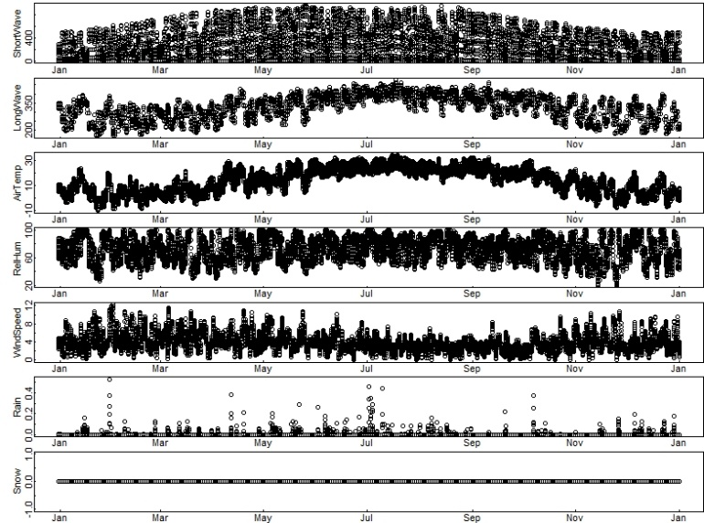

**Mendota**

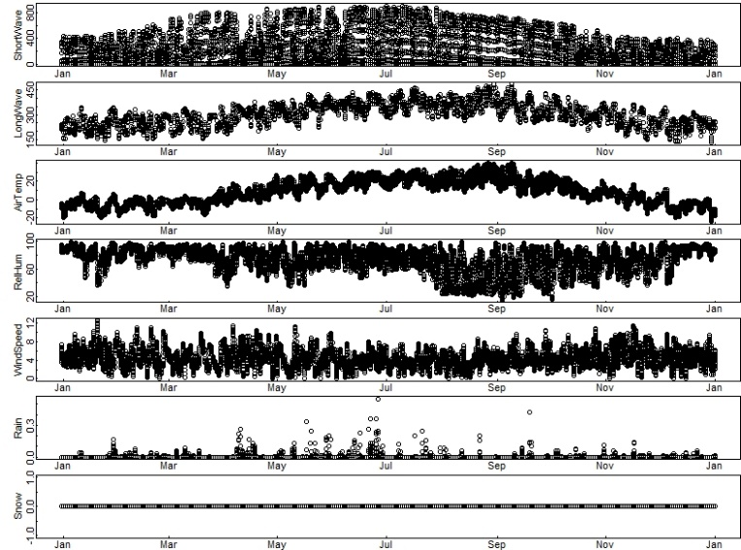

**Sunapee**

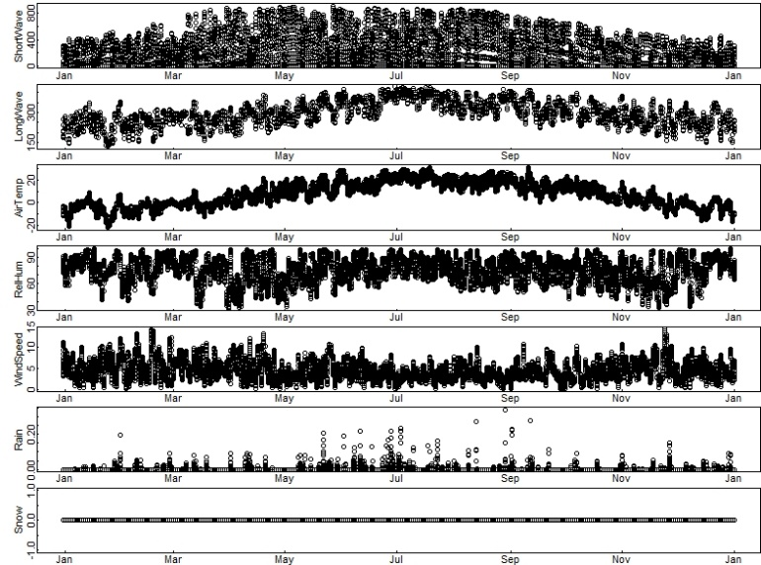

**Toolik**

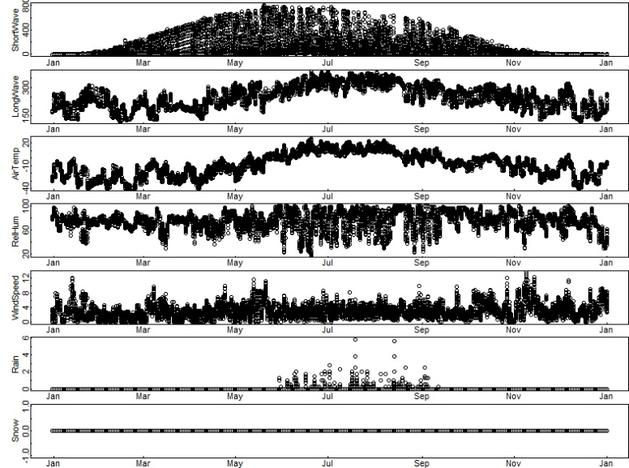

Objective 2: Baseline temperature and dissolved oxygen heatmaps and greenhouse gas line plots from GLM model output. Students should note differences in water temperature with depth, and how that changes as the year progresses. Note that in spring, the lakes begin to stratify, with warmer water near the surface (epilimnion) and cooler water deeper (hypolimnion). **Note:** It is important when comparing plots for students to note the minimum and maximum values represented by the different colors and/or y-axis labels!

**Temperature heatmaps: Baseline**

**Falling Creek**

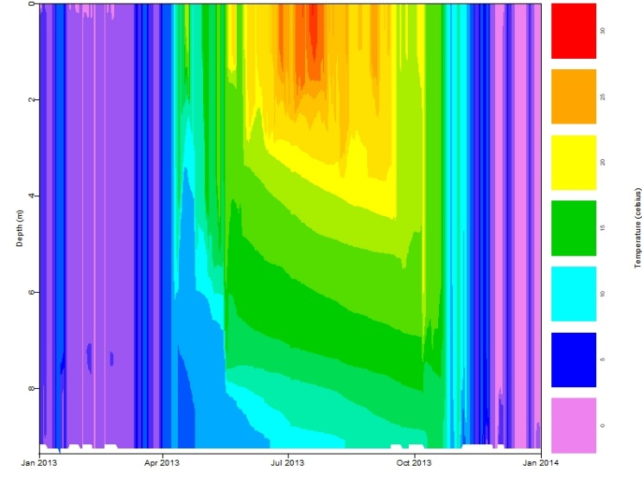

**Mendota**

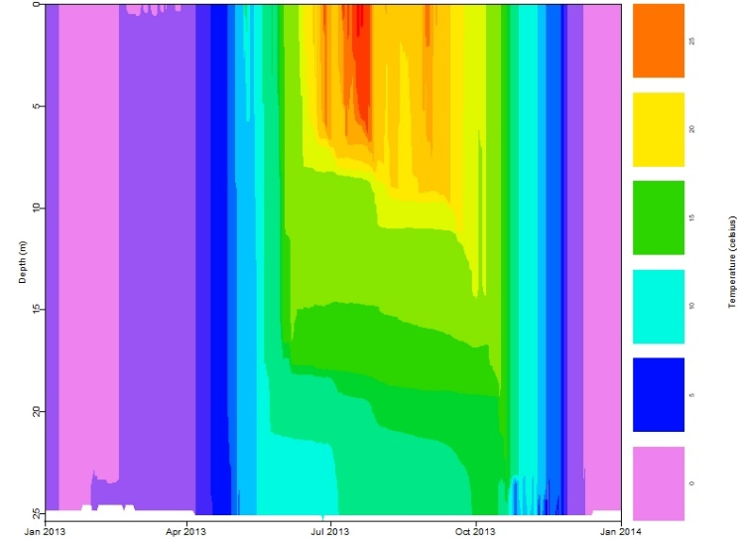

**Sunapee**

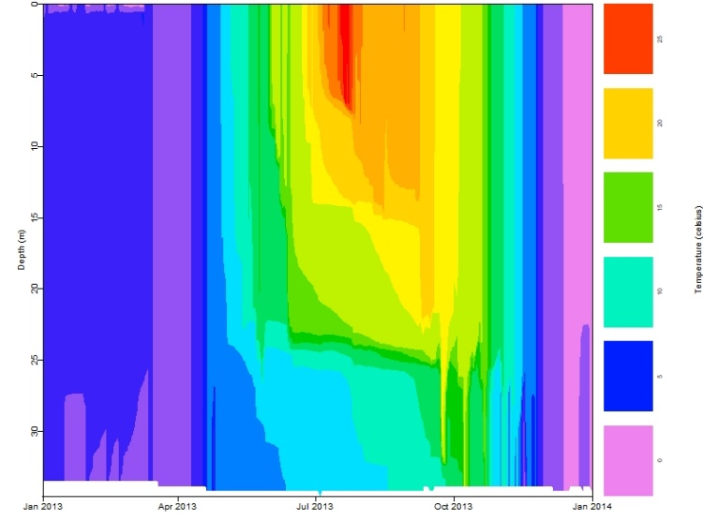

**Toolik**

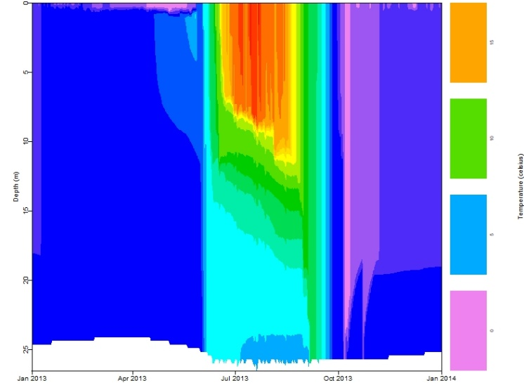

**Dissolved oxygen heatmaps: Baseline**

*Which lake has the greatest/least duration of anoxia (DO ~0 mg L-1) at the sediment-water interface under baseline conditions? How would this impact CH4 production in the bottom waters of each lake?* Under baseline conditions, Falling Creek has the greatest duration of anoxia in the bottom waters. Students may hypothesize this would result in larger CH4 fluxes from Falling Creek as compared to other lake systems. Sunapee doesn’t appear to go anoxic at the sediment-water interface and would therefore result in very little CH4 production under baseline conditions. We note that the GLM-AED model gives dissolved oxygen output in units of mmol/m3, not mg/L, but anoxic conditions are indicated by the purple color regardless of units.

**Falling Creek**

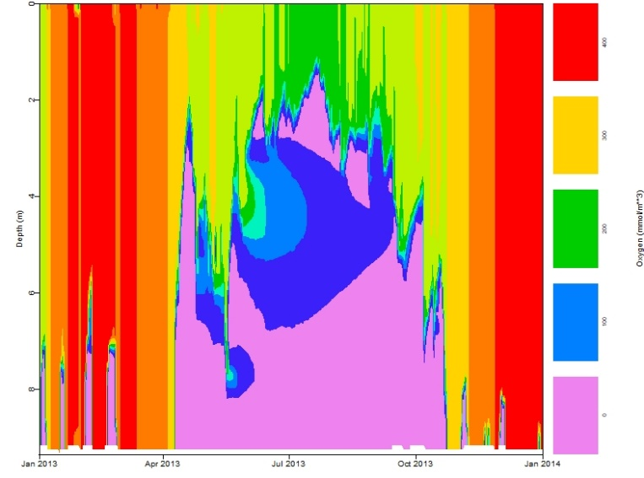

**Mendota**

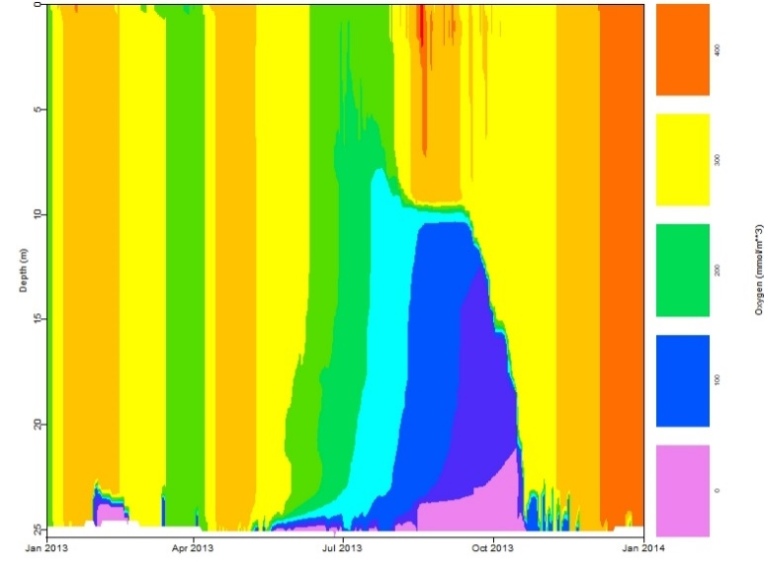

**Sunapee**

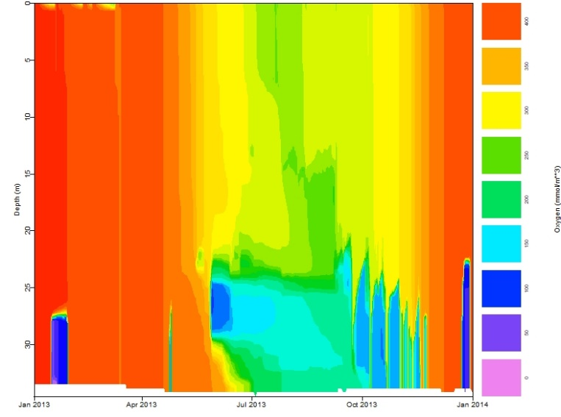

**Toolik**

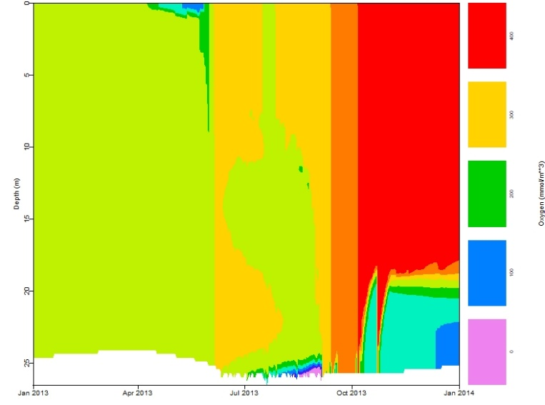

**Methane fluxes: Baseline**

*Are most lakes CH4 sinks or sources? What impact will this have on future warming? When does the highest CH4 flux occur? What lake has the highest CH4 flux? Why? Which lake has the lowest CH4 flux? Why?* All lakes are CH4 sources, which will result in greater greenhouse gas concentrations in the atmosphere leading to further warming in the future. The highest CH4 flux in each lake typically occurs following fall turn-over when the anoxic bottom waters with high CH4 concentrations mix with the surface waters, resulting in a flux of CH4. Large fluxes can also occur after ice-off in the spring when CH4 that has accumulated under the ice during winter is released to the atmosphere. The lake with the highest CH4 flux is Falling Creek because it has the greatest extent of anoxia at the sediment-water interface (see discussion above). The lake with the lowest CH4 flux following fall turn-over is Sunapee. Because the bottom waters never truly become anoxic, there is very little CH4 production in the bottom water and thus, very little CH4 flux following fall turn-over. All methane fluxes here are shown in units of mmol/m2/day; note that each lake's panel's y-axis varies.

**Falling Creek**

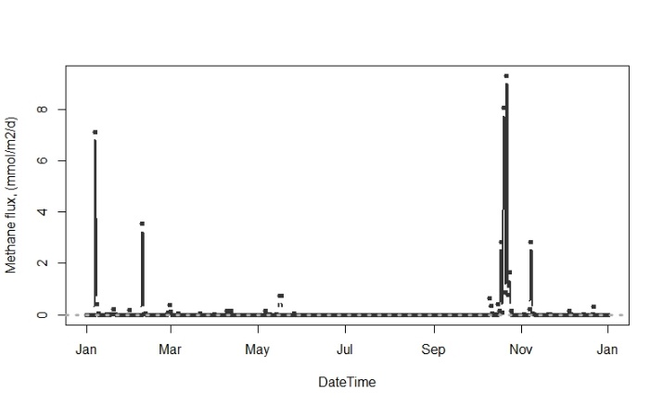

**Mendota**

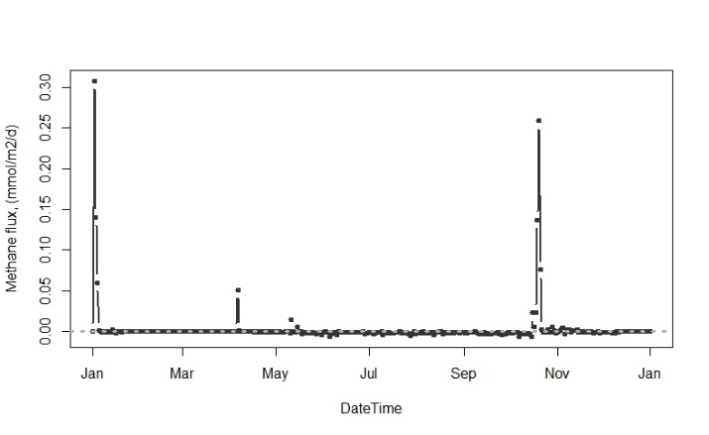

**Sunapee**

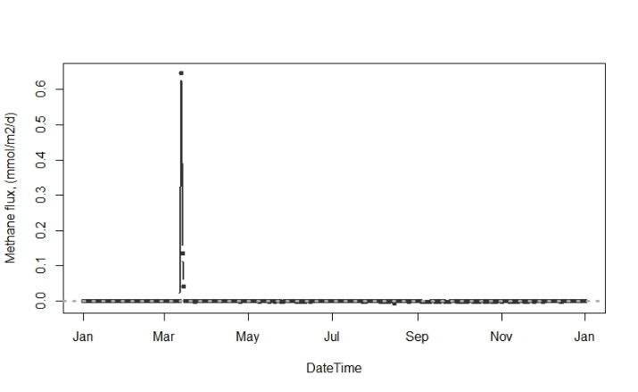

**Toolik**

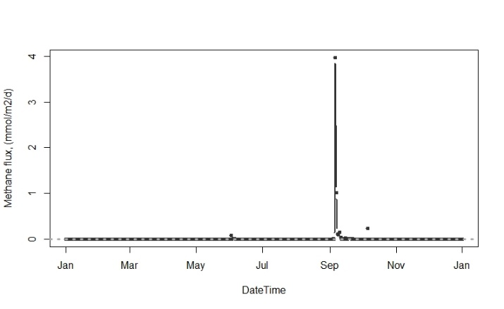

**Carbon dioxide fluxes: Baseline**

*Which lakes are CO2 sources and which lakes are CO2 sinks to the atmosphere under baseline conditions? Why might this be the case?* Falling Creek and Mendota are both CO2 sinks because they are both eutrophic such that primary production is greater than microbial respiration. Sunape and Toolik are both CO2 sources because they are oligotrophic and primary production is much lower than microbial respiration. Note that for Toolik, the ice-off period is much shorter than for the temperate lakes, and so the period of CO2 relase is much smaller. All carbon dioxide fluxes here are shown in units of mmol/m2/day; note that each lake's panel's y-axis varies.

**Falling Creek**

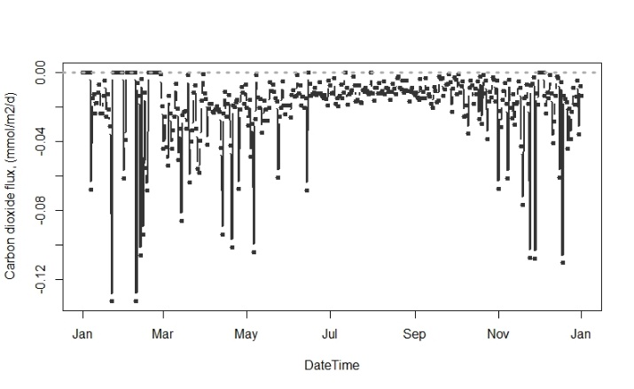

**Mendota**

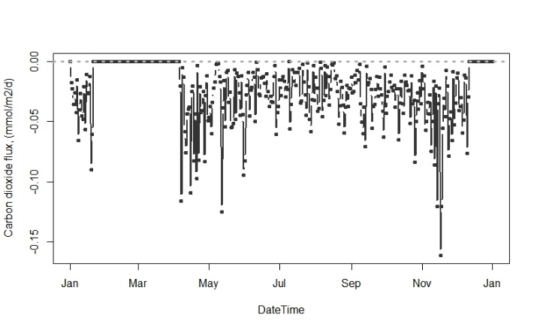

**Sunapee**

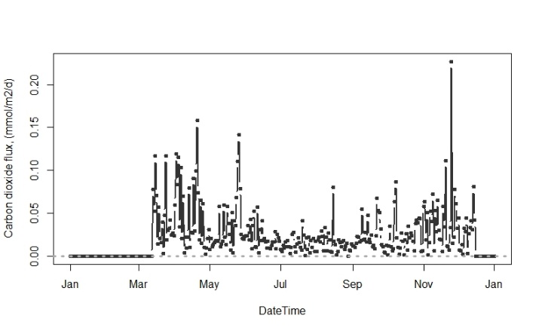

**Toolik**

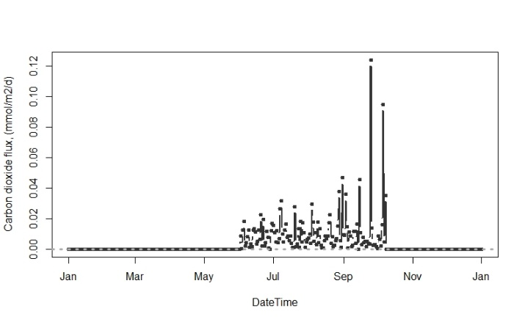

## Activity B

Objective 3: Select a climate change scenario

In looking at model outputs, the most important goal of this activity is for students to explain: 1) How they predicted the change in climate would alter greenhouse gas emissions (identifying their hypothesis), and 2) Whether the model output supported their hypothesis (and why they think it did or did not). We recommend that student pairs make a very brief presentation to the rest of the class, explaining these elements and sharing figures (e.g., heatmaps) from the model output that show how their lake responded to the scenario. We encourage the instructor to ask questions of the students after their presentation to stimulate discussion, such as: *Did you expect that the lake would respond in this way to your climate scenario? Why or why not? What was surprising to you in this model output? Do you think that this scenario is realistic?*

**Methane fluxes:** only examples for the +6 oC climate scenarios are plotted.

*How did the pattern of CH4 fluxes change seasonally? Why did CH4 fluxes following turnover increase? Which lake now has the greatest CH4 flux? Why? Which has the smallest CH4 flux? Why?* CH4 fluxes for all lakes shifted later in the year as fall turnover occurs later under warming conditions. The magnitude of CH4 flux following fall turnover increased for Falling Creek, Mendota, and Toolik. Have students analyze the heat maps of dissolved oxygen to help explain why. Possible answers will likely focus on that the duration and extent of anoxia at the sediment-water interface increased for all lakes (except Sunapee). Sunapee still has very low CH4 emissions. Unlike the other lakes, the sediment-water interface still never reaches anoxia, even in the warmest scenario, resulting in very little to no CH4 production. For Sunapee, spring turn-over now occurs earlier in the year and results in less CH4 released from the lake.

**Falling Creek**

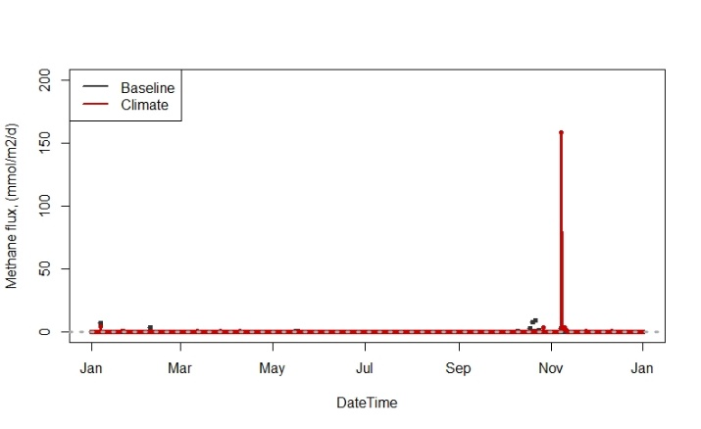

**Sunapee**

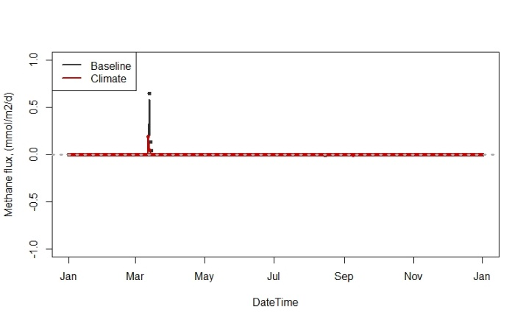

**Mendota**

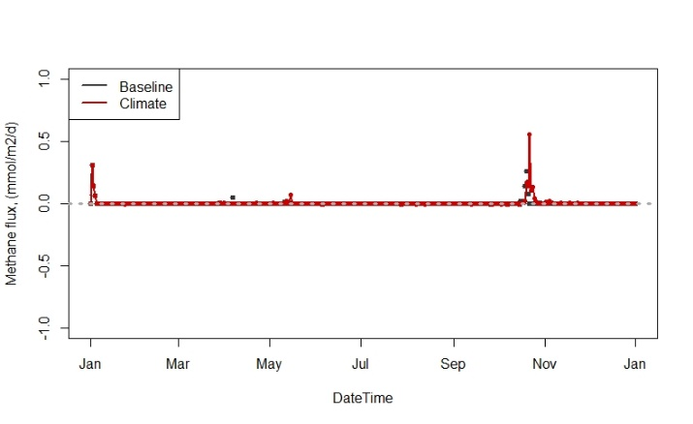**Toolik**

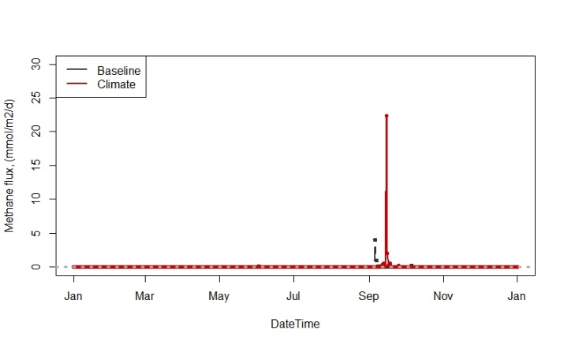

**Carbon dioxide fluxes:** only examples for the +6 oC climate scenarios are plotted.*How do CO2 fluxes change under predicted warming scenarios? Why?* Generally, the magnitude of CO2 fluxes for all lakes remained the same as during baseline conditions, however, the duration of the period of CO2 uptake (negative fluxes; Falling Creek and Mendota) or CO2 release (positive fluxes; Sunapee and Toolik) increased. This is largely due to decreasing duration of ice-on during the winter period and/or increased duration of phytoplankton blooms in eutrophic lakes (i.e., Falling Creek and Mendota) under warming climate scenarios. Falling Creek and Mendota remained a CO2 sink under warming conditions, while Sunapee and Mendota remained CO2 sources.

**Falling Creek**

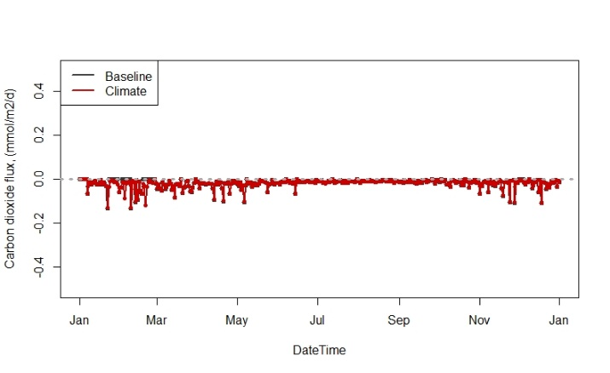

**Sunapee**

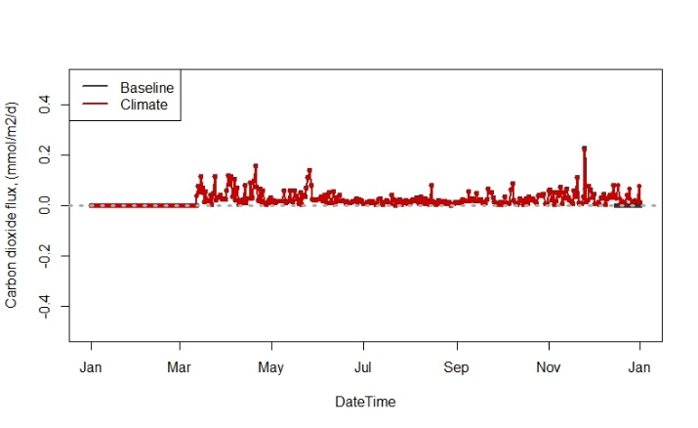

**Mendota**

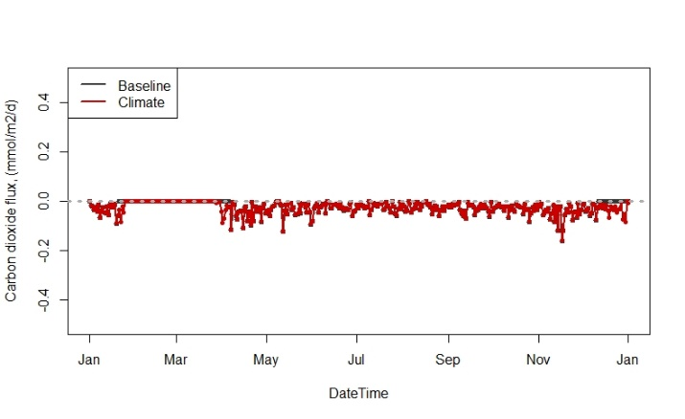

**Toolik**

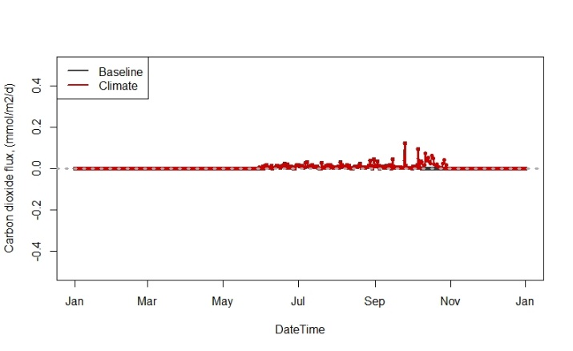

## Activity C

Objective 5: Calculate the global warming potentials (GWPs) of your lake under both baseline and climate change scenarios

After running the baseline and climate warming scenario, students will calculate GWPs and produce bar plots showing how the GWP from CO2 and CH4 changed across their scenarios. *Ask students whether their plot provides any evidence of macroscale feedbacks, and why?*

The following graphs are not produced by students, but show the full range of GHG fluxes or GWP estimates across all three scenario options (+2, +4, or +6°C). Note that the y-axes differ substantially between lakes. It’s important to remind students that fluxes are calculated for the entire lake surface; therefore, larger lakes will inherently have larger fluxes (due to greater surface area!) than smaller lakes.

**GHG Fluxes:**

**Falling Creek**

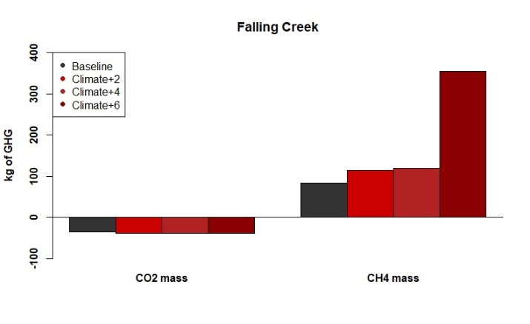

**Mendota**

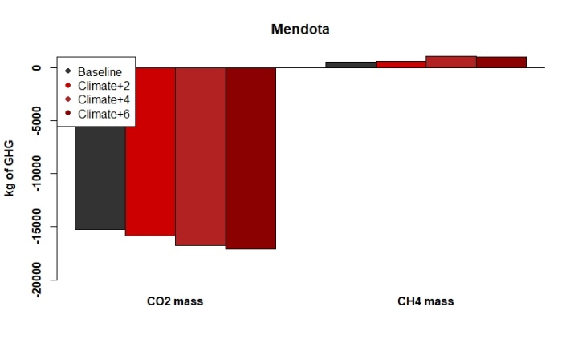

**Sunapee**

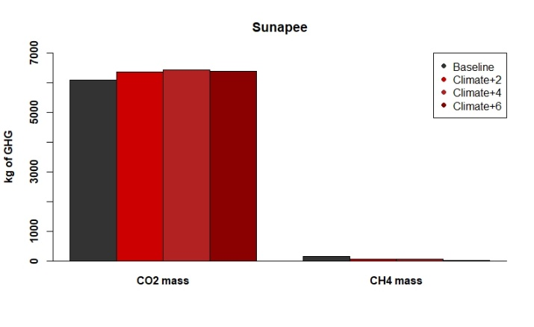

**Toolik**

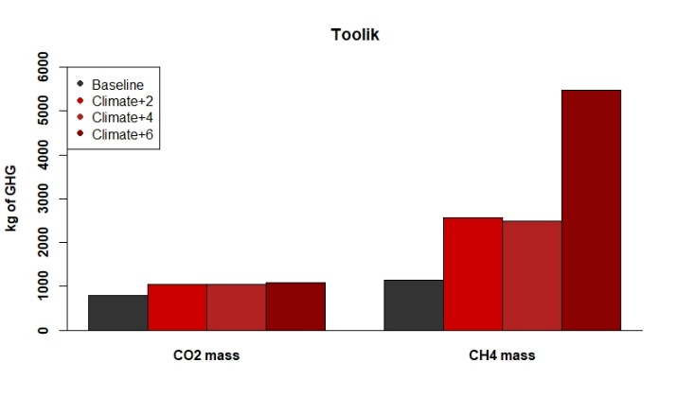

**GWP Estimates:**

**Falling Creek**

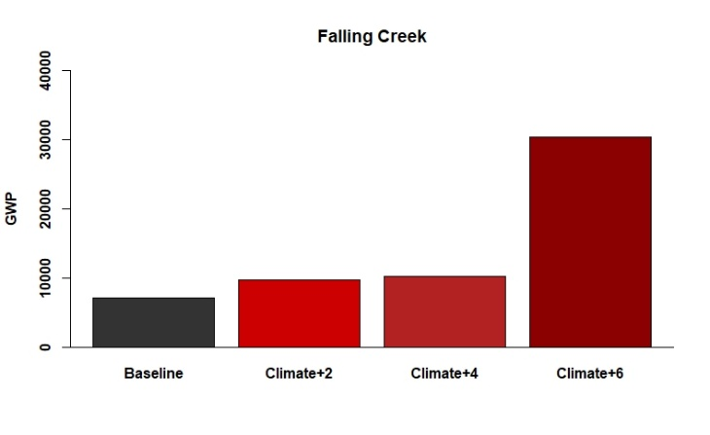

**Mendota**

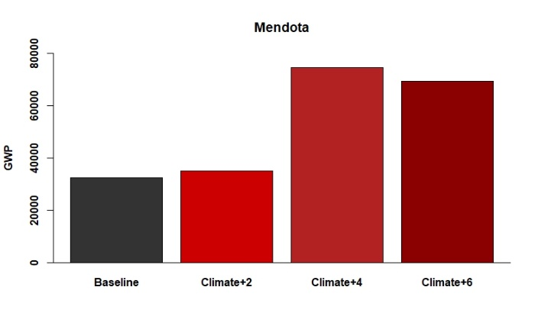

**Sunapee**

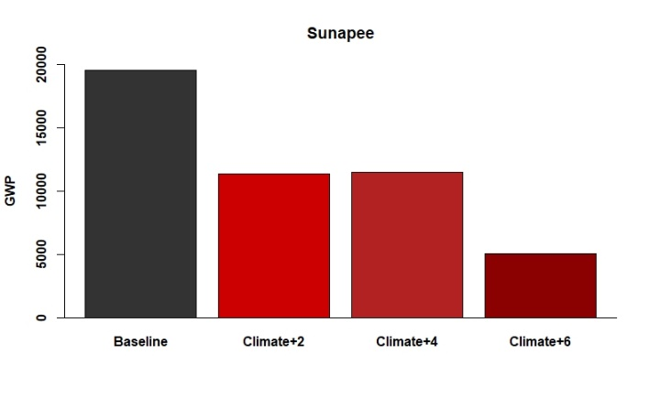

**Toolik**

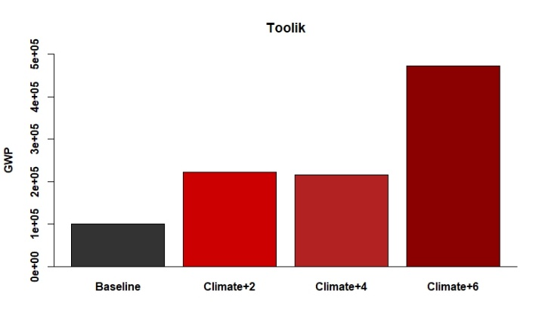

**Questions and notes:**

*Why does the GWP of some lakes increase non-linearly with warming?* GHG dynamics are non-linear and uncertain! While we have a good idea of how individual processes (i.e., phytoplankton production, microbial respiration) will impact GHG emissions, it’s really difficult to predict how all of these individual processes will interact simultaneously to ultimately change GHG emissions for the entire ecosystem. These interacting processes are often non-linear and respond to changing temperatures and dissolved oxygen concentrations in ways that are difficult to predict. This is why we use ecosystem models! Models represent our best estimates for what might happen in the future and therefore are inherently uncertain.

*Why does the GWP of Sunapee decrease with climate warming?* This is likely because CH4 production rates are highly sensitive to temperature. Sunapee experienced hypolimnetic cooling, likely driving lower CH4 production and fluxes and subsequent GWP. The hypolimnion in Sunapee cools as air temperatures increase due to increased thermal stratification, preventing warm surface water from reaching the sediments. Rates of CH4 production were already low because the duration and extent of anoxia in the hypolimnion is low. Thus, very little CH4 is produced at the sediment-water interface and actually decreases under air temperature warming scenarios.

*Which is more important in predicting the GWP of lake ecosystems: CH4 ­or CO2? Why?* Overall, CH4 fluxes dominate the GWP because CH4 is 86x more potent of a GHG than CO2 over a 20-year time span. Most of the changes in GWP in the future are due to increases in CH4 released from lakes. A good discussion question for the students is to ask, What are the implications of the increased potency of CH4 (relative to CO2) for climate change in the future? How does this relate to macro-scale feedbacks?

*Which lake has the greatest GWP under future climate scenarios? Why?*Toolik has the greatest change in GWP for the climate scenarios; this is likely because the hypolimnetic water temperatures increase more for Toolik than other lakes and the extent (i.e., duration) of anoxia in the hypolimnion increases the most. This results in an increase in CH4 produced at the sediments under warmer, more anoxic conditions which results in greater CH4 flux from the lake.

*Which lake has the smallest GWP source under future climate scenarios?* Sunapee is the smallest source of GWP under warming conditions due to the decreasing amount of CH4 produced at the sediment-water interface due to hypolimnetic cooling (see above).

Additional discussion points:

*We have only increased air temperature in the climate scenarios, but there are likely many other factors that will cause lakes to change under future conditions.* Have students discuss additional ways lakes may change in the future and how this might alter GHG emissions from these systems. This could include things like: changes in land use and nutrient loading; changes in precipitation (inputs of nutrients and carbon); non-linear changes in temperature throughout the year, etc.

*Students will find in their comparisons of total emissions from each lake that lake area has a large impact on the total GHGs emissions.* Have students use R to calculate the amount of GHG emissions for their model lake per area (i.e., divide the total GWP by lake area to standardize the fluxes), then compare the GWP of each lake on a per area basis as a class and discuss which systems emit the most GWP on a per area basis.

*Toolik Lake is located in the Arctic, where climate impacts are predicted to be most severe and where there is a disproportionately large number of lakes. What does this mean for the future role of Arctic lakes in climate change?* Discuss as a class the role Arctic lakes may play in accelerating GHG emissions from lakes and how this may impact the rate of future climate warming.

*And get creative! There are many different discussion points that can come out of this exercise. We encourage instructors to tailor the modeling results discussion to what has already been discussed in previous classes or the research interests of you (the instructor!) or the students.*